Israeli-Palestinian Conflict   
In Aftermath of 2023 War (initiated by Hamas on 10/8/2023)

**Morning Joe (12/1/2023)**

**The hostage exchange during the 6-ceasefire in Nov. 2023.**

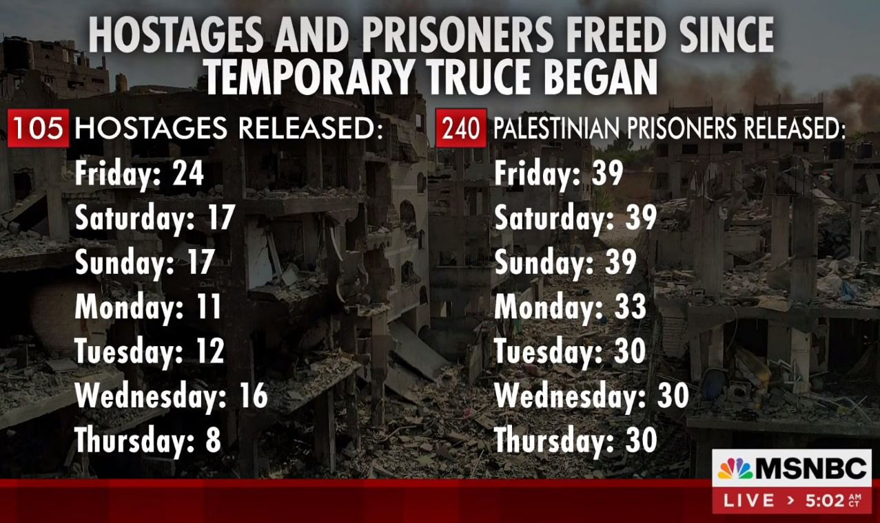

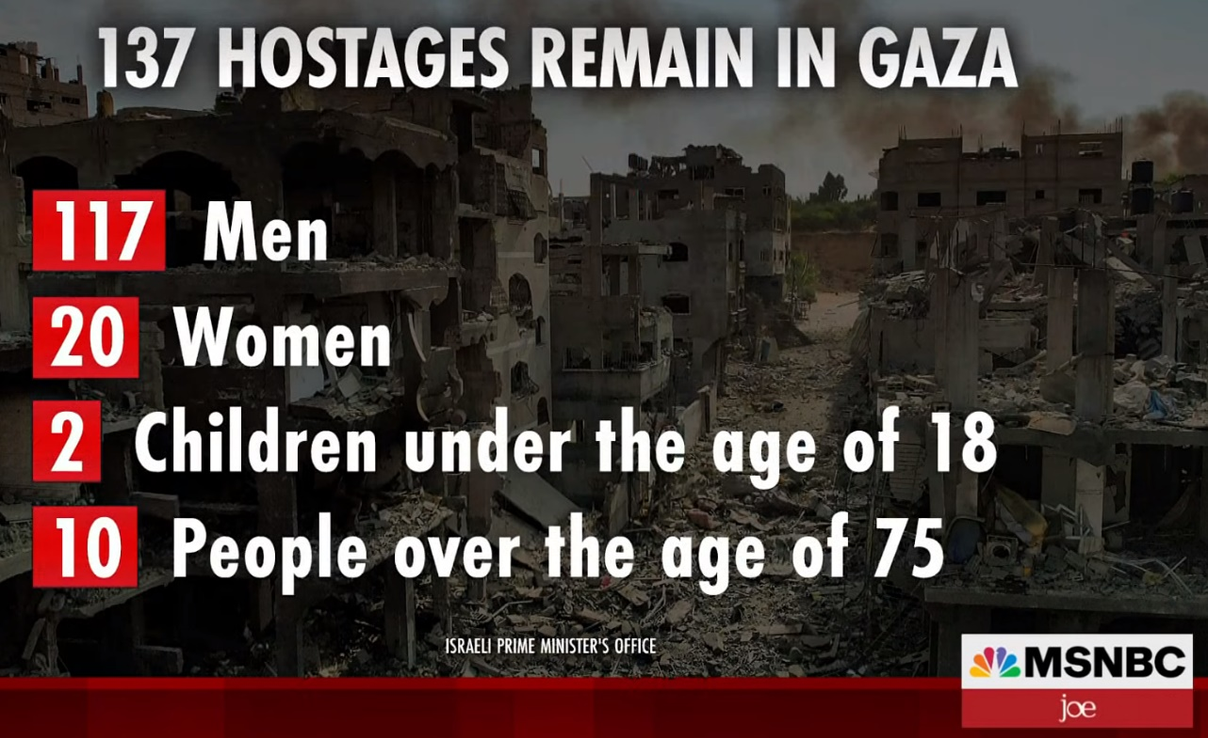

**Israel knew about Hamas’s plan to attack a year ago, a plan that Hamas had been developing for 11 years, since 2012. Israeli intelligence believed the plan was aspirational, that Hamas was in no position to carry it out. The Hamas plan called for 1680 commandos to cross the border in 60 different locations, but Israeli intelligence believed that only 70 Hamas militants could cross in 2 locations.**

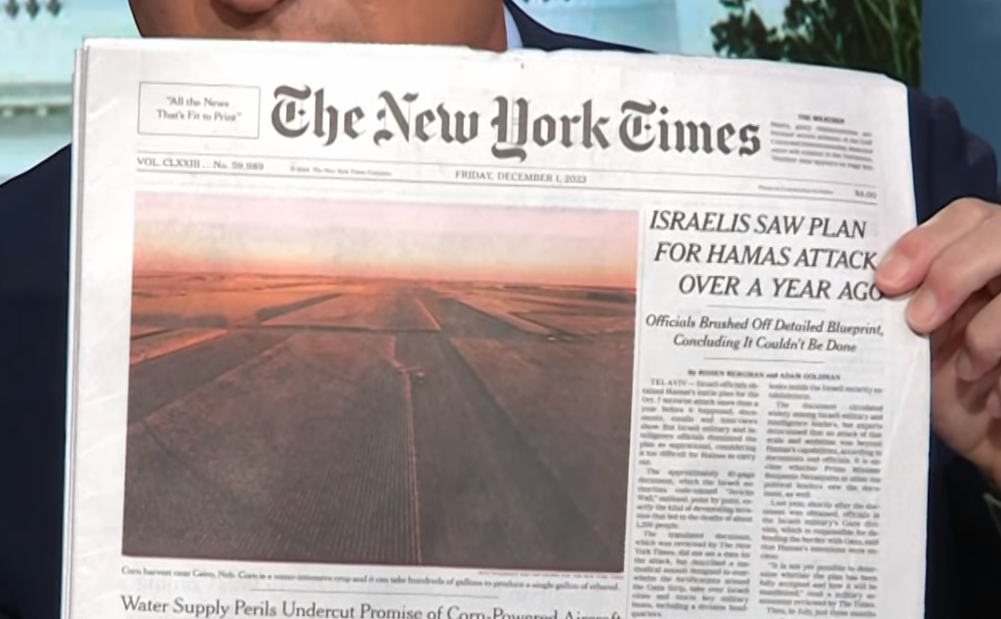

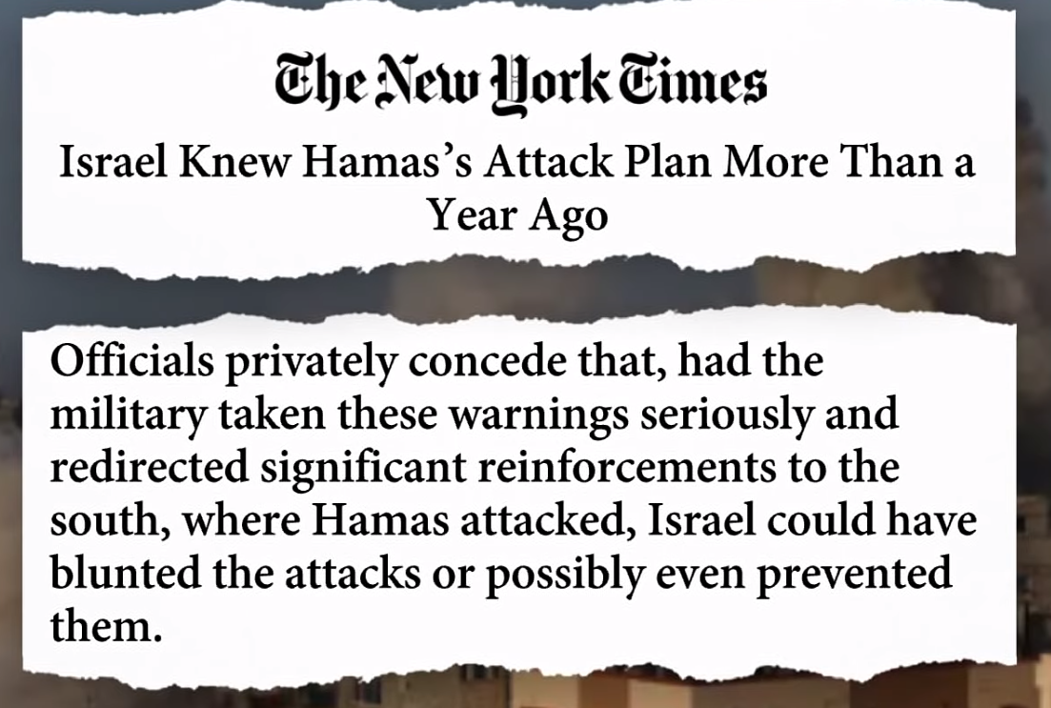



**MSN.com (11/15/2023)**

**The Kibutz system was “communism practiced the way it was supposed to be”**

[‘All they want to do is murder Jews’: The Israeli peace activists slaughtered by Hamas (msn.com)](https://www.msn.com/en-us/news/world/all-they-want-to-do-is-murder-jews-the-israeli-peace-activists-slaughtered-by-hamas/ar-AA1jYH9Z?ocid=msedgntp&pc=ACTS&cvid=ce2283280202497c95303b0cf32e23e4&ei=35) <https://www.msn.com/en-us/news/world/all-they-want-to-do-is-murder-jews-the-israeli-peace-activists-slaughtered-by-hamas/ar-AA1jYH9Z?ocid=msedgntp&pc=ACTS&cvid=ce2283280202497c95303b0cf32e23e4&ei=35>

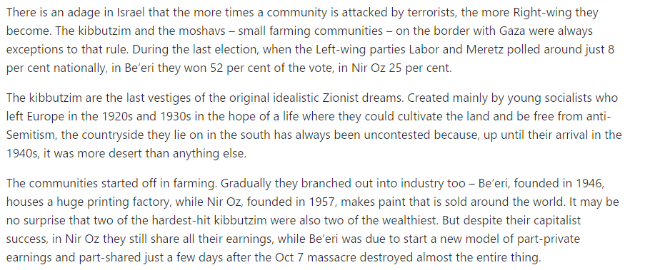

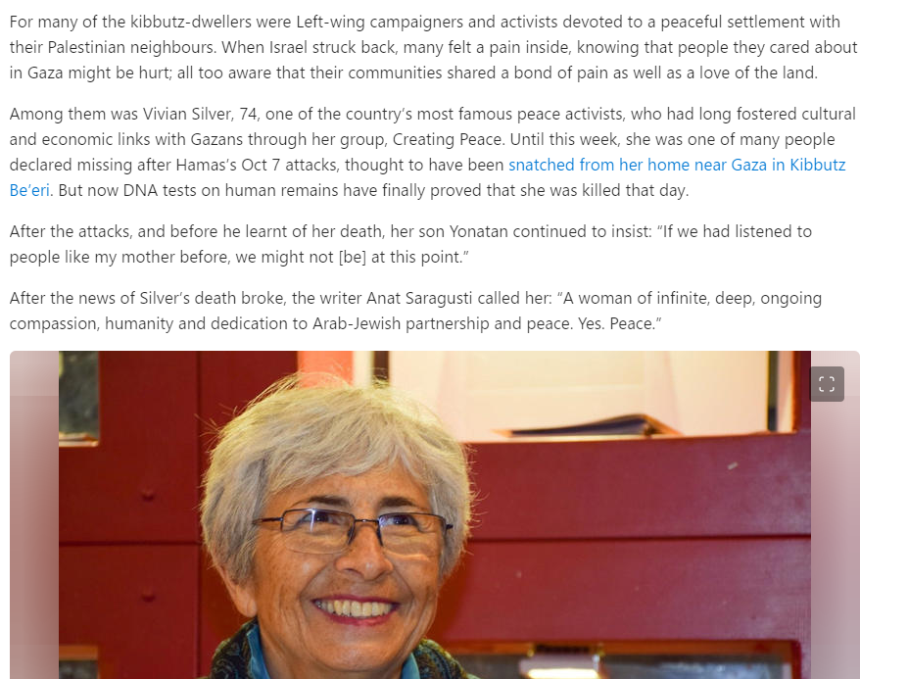

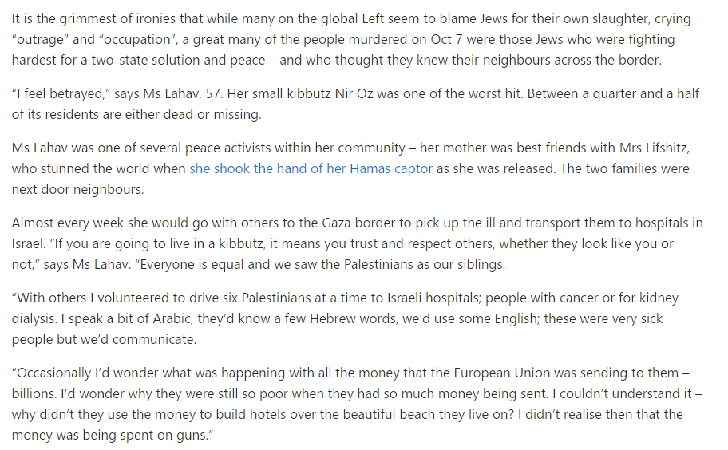

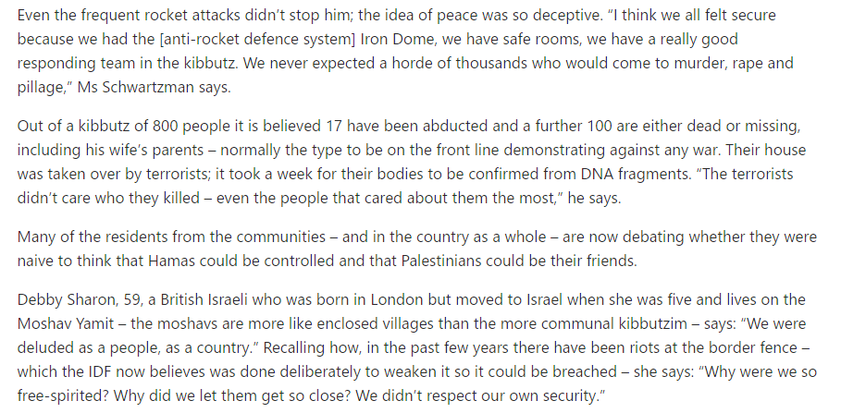

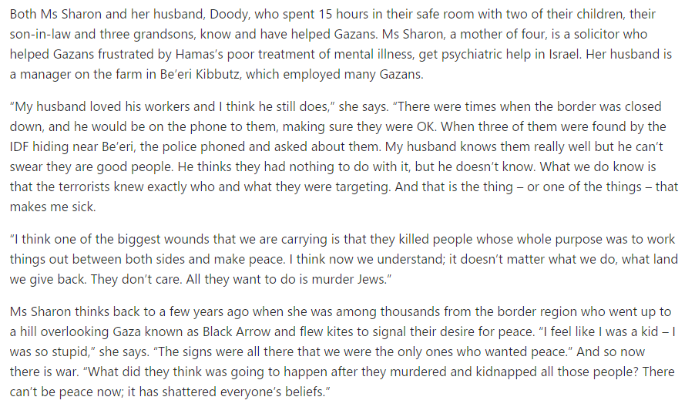

**MSN.com (11/6/2023)**

**A student letter endorsed by faculty at Columbia and Barnard Universities.**

[‘Being a Jew at NYU right now is scary’: Student | Fox News Video](https://www.foxnews.com/video/6340374520112) <https://www.foxnews.com/video/6340374520112>

[Columbia-Barnard Faculty Support Israel-Gaza Student Protesters (thewrap.com)](https://www.thewrap.com/columbia-barnard-faculty-israel-gaza-student-protests-open-letter/) <https://www.thewrap.com/columbia-barnard-faculty-israel-gaza-student-protests-open-letter/>

[Columbia Faculty Letter: Grave Concerns About the Well-Being of Our Students - Google Docs](https://docs.google.com/document/d/1cVLg6RTnqd2BTzuouWbfACnFEex7GQeImDZJnMlUReM/preview?pli=1) <https://docs.google.com/document/d/1cVLg6RTnqd2BTzuouWbfACnFEex7GQeImDZJnMlUReM/preview?pli=1>

[Joint Statement from Palestine Solidarity Groups at Columbia University regarding the recent events in Palestine/Israel: Oppression Breeds Resistance. (google.com)](https://docs.google.com/forms/d/e/1FAIpQLSeHe5p0in9g4h9xURoTx6NPn-v2rb-m7k6ZIm4YNGqOPRVsFQ/viewform) <https://docs.google.com/forms/d/e/1FAIpQLSeHe5p0in9g4h9xURoTx6NPn-v2rb-m7k6ZIm4YNGqOPRVsFQ/viewform>



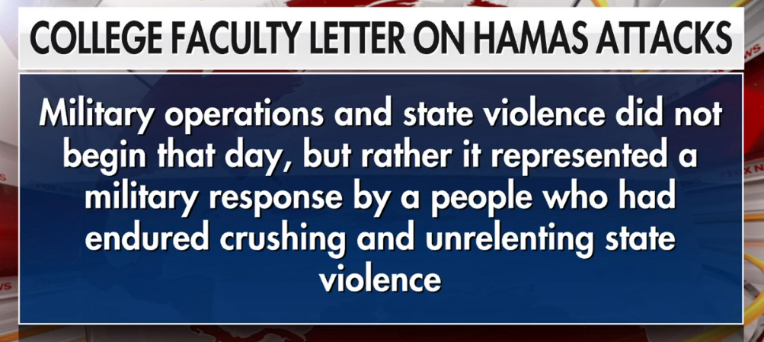

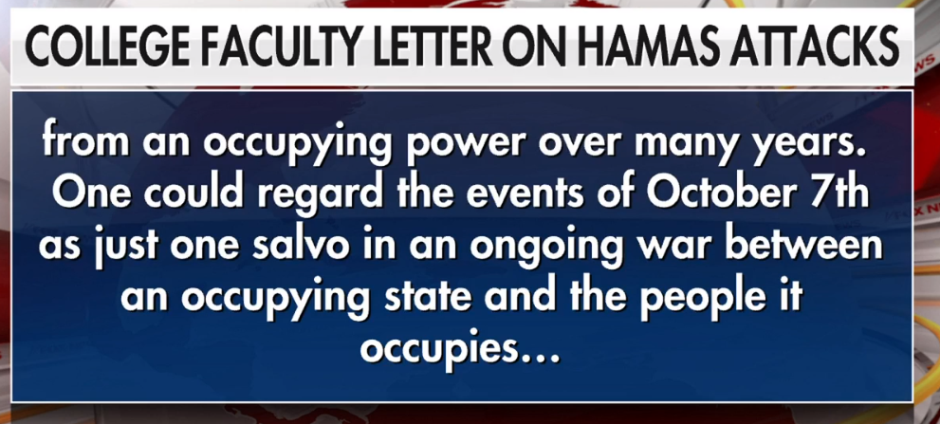

**MSN.com (10/25/2023)**

[Rich Hollywood Elites Are Learning Democrats Are Bigots (msn.com)](https://www.msn.com/en-us/movies/celebrity/rich-hollywood-elites-are-learning-democrats-are-bigots/ar-AA1iN1XR?ocid=msedgntp&pc=ACTS&cvid=6c82ef6ac2c6400f875a694be91b60fd&ei=27) <https://www.msn.com/en-us/movies/celebrity/rich-hollywood-elites-are-learning-democrats-are-bigots/ar-AA1iN1XR?ocid=msedgntp&pc=ACTS&cvid=6c82ef6ac2c6400f875a694be91b60fd&ei=27>



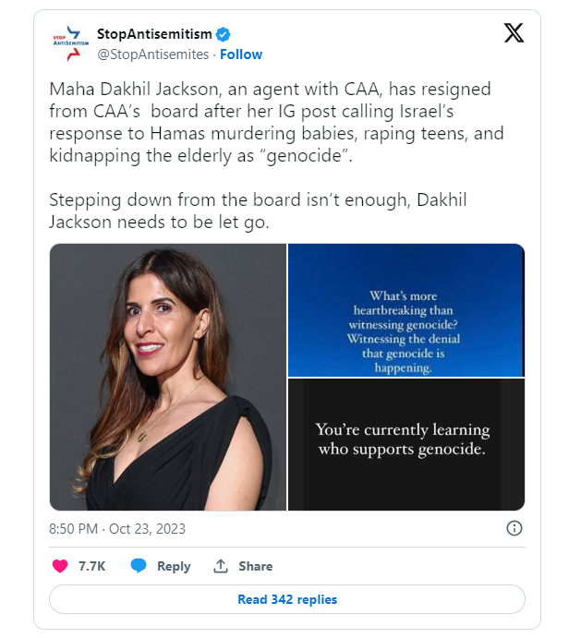

**MSNBC (Morning Joe) (10/19/2023)**

**Support for Hamas (Blaming Israel for the Violence) on University Campuses**

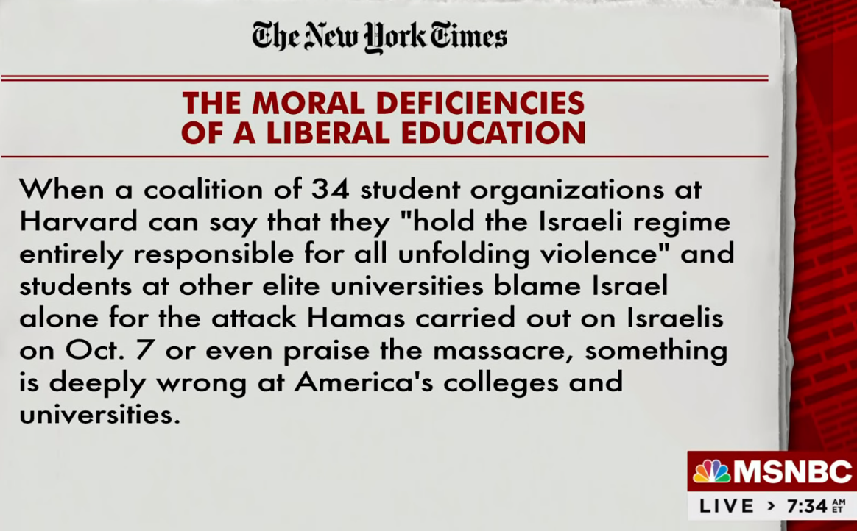

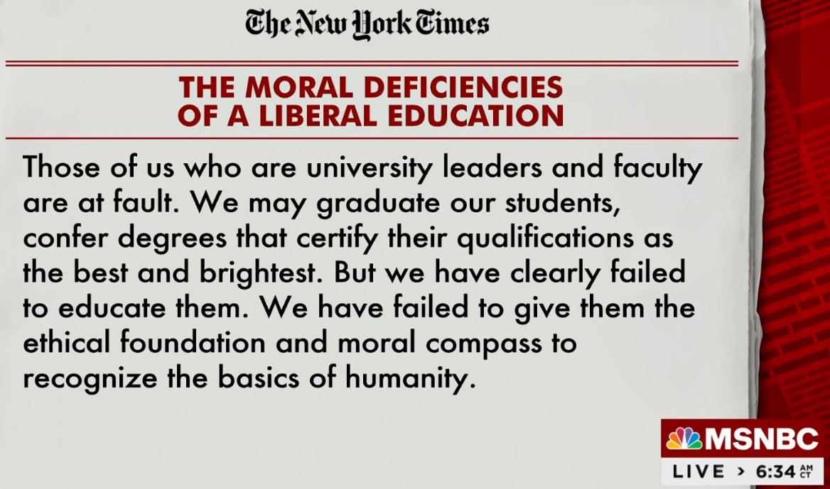

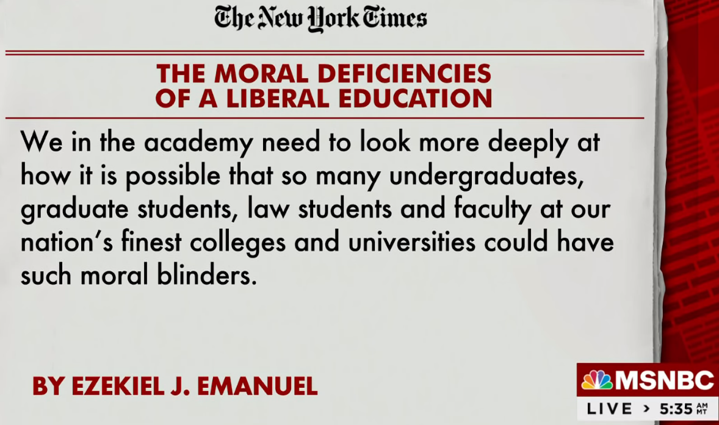

**The Bombing of the Hospital in Southern Gaza**

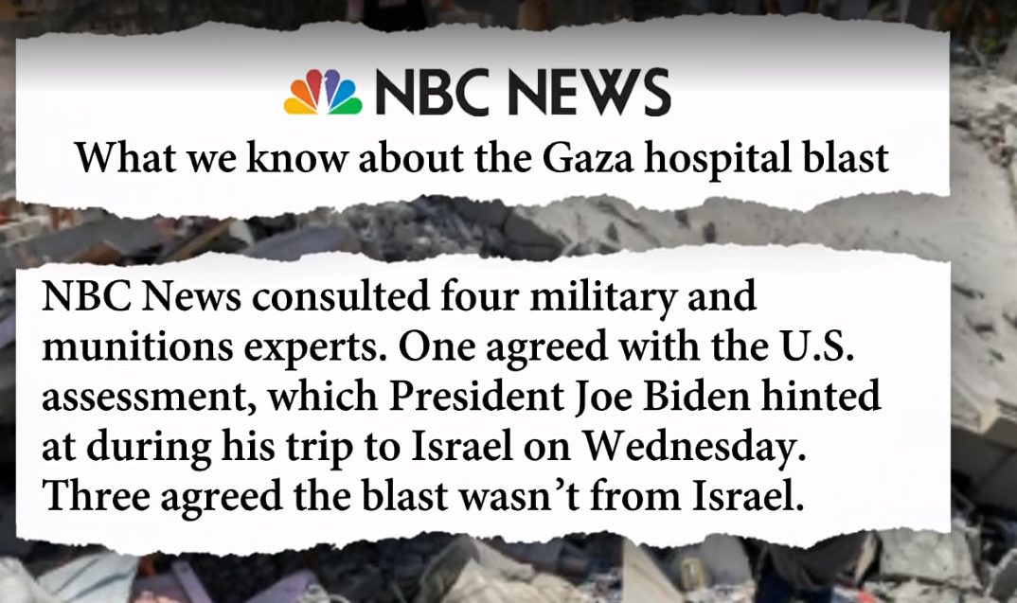

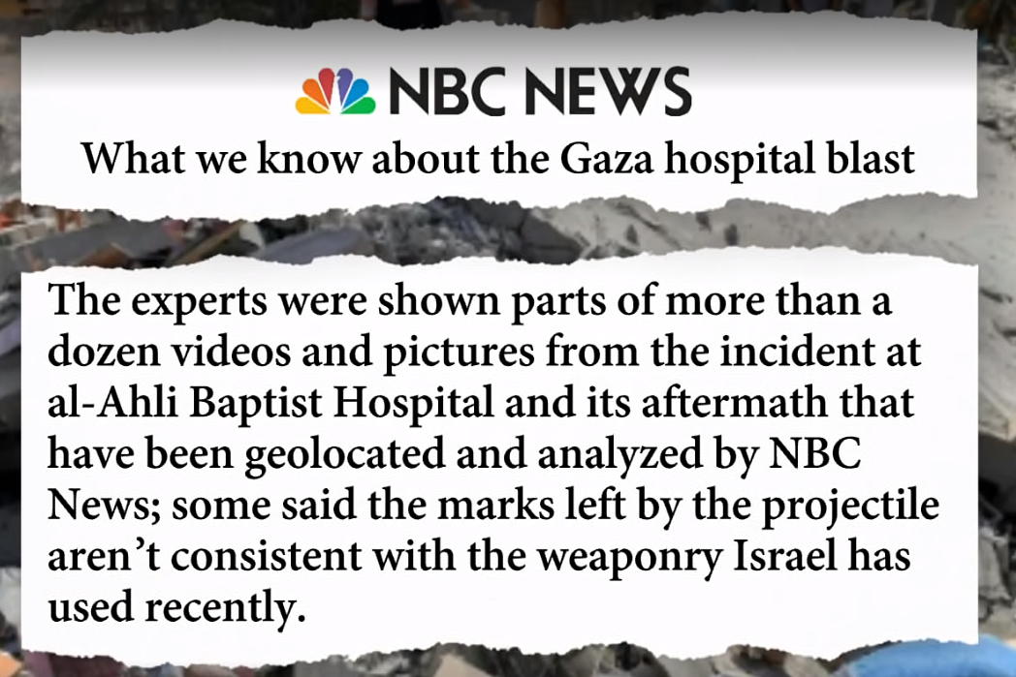

**CNN (Fareed Zakaria) (10/15/2023)**

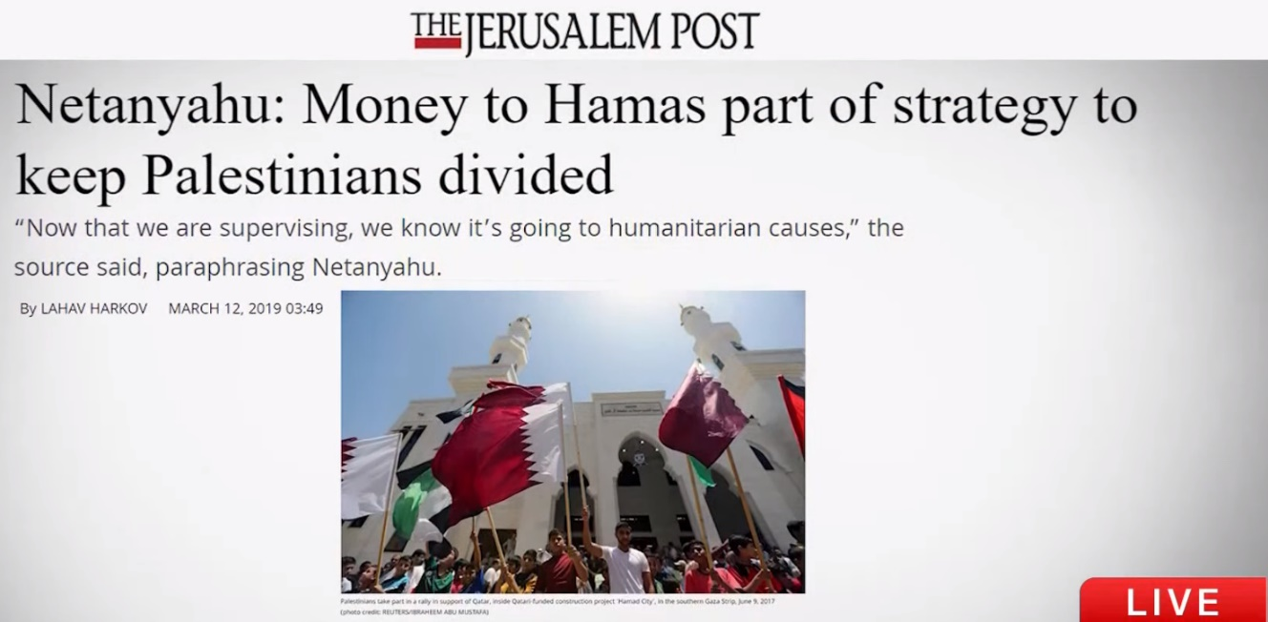

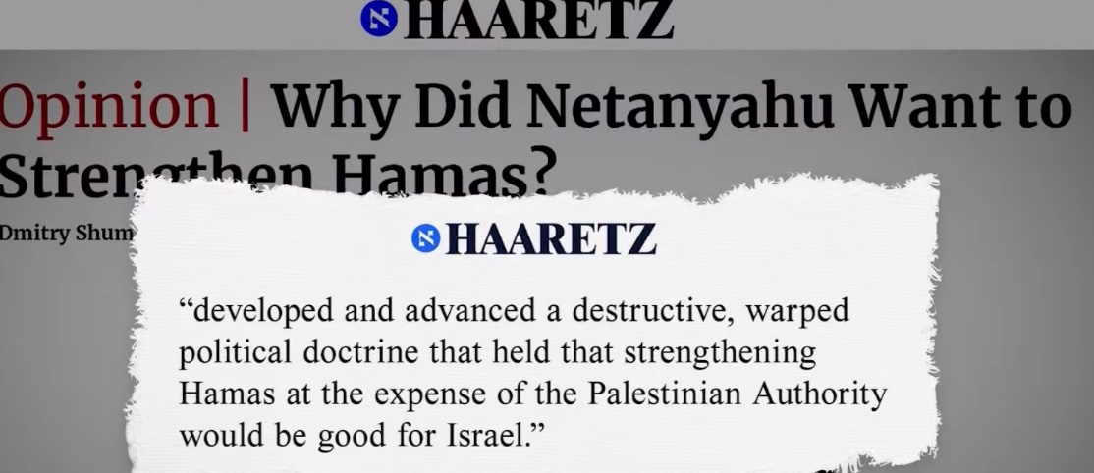

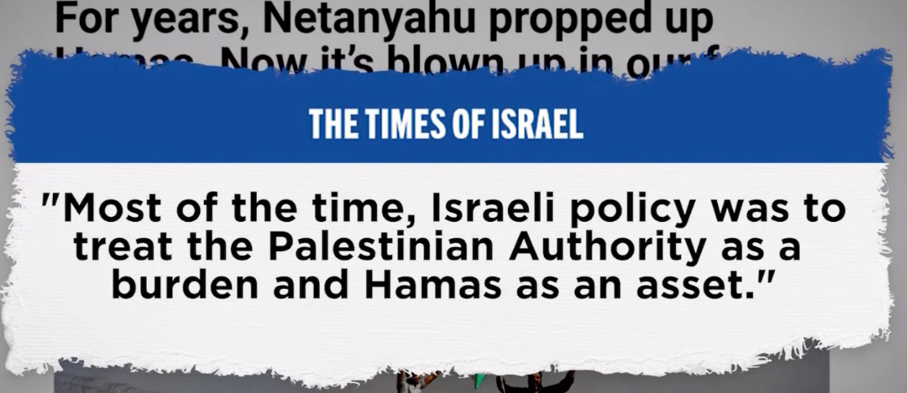

**MSN.com (10/12/2023)**

[Harvard student groups issued an anti-Israel statement. CEOs want them blacklisted (msn.com)](https://www.msn.com/en-us/money/companies/harvard-student-groups-issued-an-anti-israel-statement-ceos-want-them-blacklisted/ar-AA1i2Z5P) <https://www.msn.com/en-us/money/companies/harvard-student-groups-issued-an-anti-israel-statement-ceos-want-them-blacklisted/ar-AA1i2Z5P>

**Cover of NY Post (10/11/2023)**

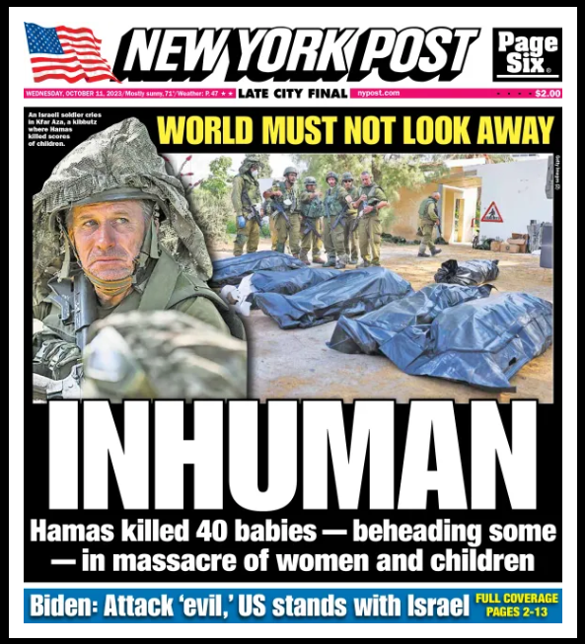

**Hannity (Fox News) (10/10/2023)**



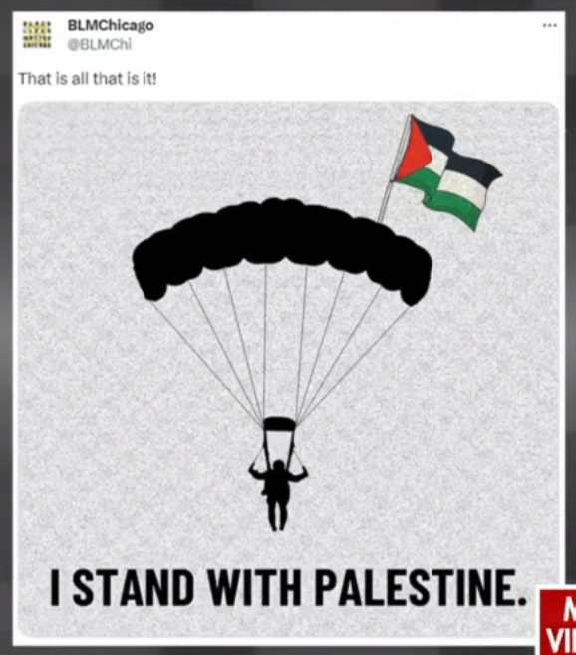

**10/11/2023**

[Full List of US Universities Staging Pro-Palestinian Protests (msn.com)](https://www.msn.com/en-us/news/world/full-list-of-us-universities-staging-pro-palestinian-protests/ar-AA1i2YZ2?ocid=msedgntp&cvid=b8676c2ea61e4333a1e1b0c957ab84fe&ei=9) <https://www.msn.com/en-us/news/world/full-list-of-us-universities-staging-pro-palestinian-protests/ar-AA1i2YZ2?ocid=msedgntp&cvid=b8676c2ea61e4333a1e1b0c957ab84fe&ei=9>

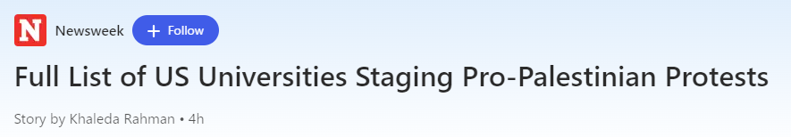

**Protests/Statements at Universities**

Harvard

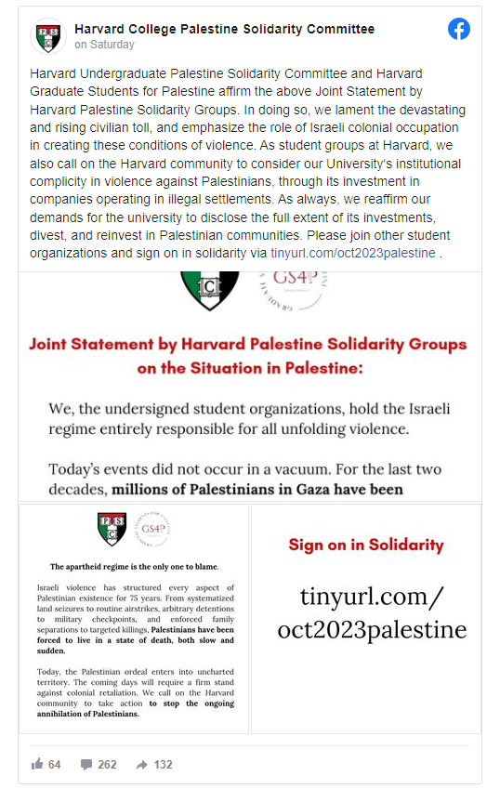

Arizona State University

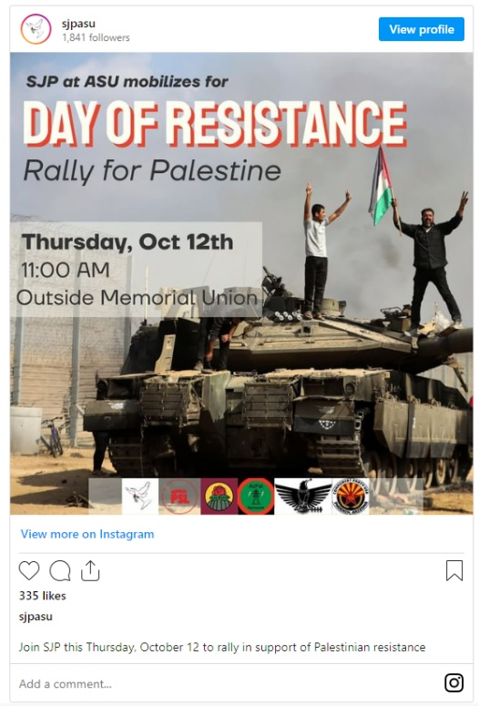

UNC  
[free Palestine. from the river to the sea 🇵🇸 recommended attire: masks and plain clothes, face coverings cosponsoring orgs // @uncydsa … | Instagram](https://www.instagram.com/p/CyPD0U4pj-t/) <https://www.instagram.com/p/CyPD0U4pj-t/>

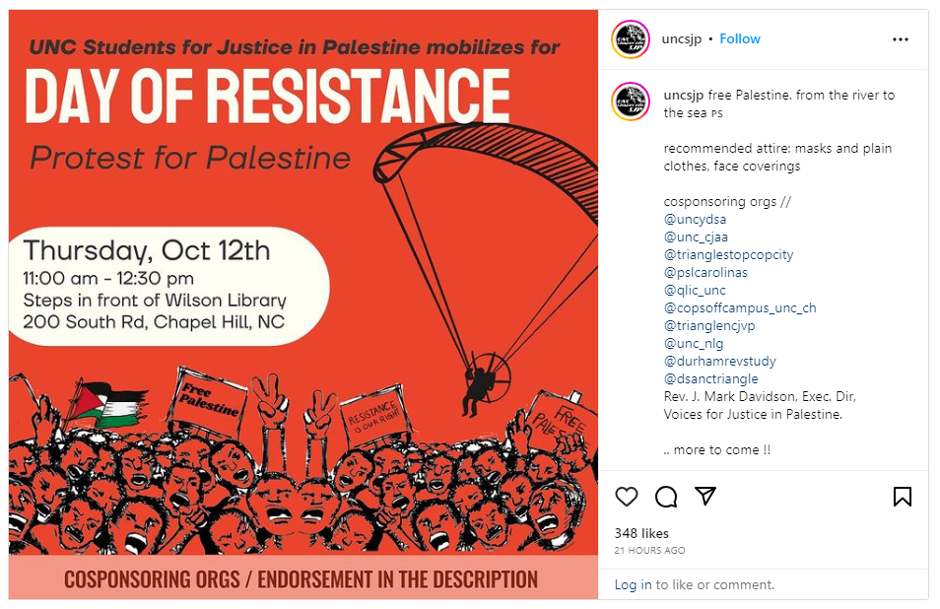

**Cover of NY Post (10/10/2023)**

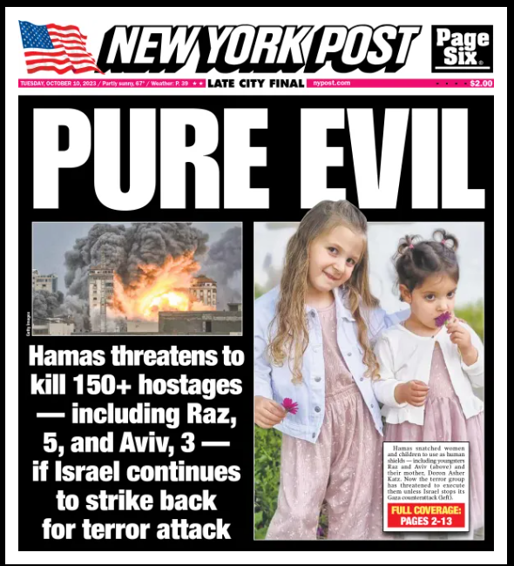

**Cover of NY Post (10/9/2023)**

